US Department of Education Newsletter

March 2018


PROGRAM NEWS

Google Map of International and Foreign Language Education Grant Recipients, Fiscal Year 2017
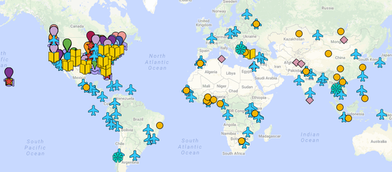

Explore our user-friendly Google map of FY 2017 International and Foreign Language Education (IFLE) grantees to learn more about the institutions that are currently funded under Title VI and Fulbright-Hays programs administered by IFLE. You will discover some of the projects being implemented on campuses across the country and throughout the world that are strengthening international and foreign language education for all!


Upcoming Fulbright-Hays Group Projects Abroad Program Targets Rural Educators
The University of Arizona Center for Middle Eastern Studies is partnering with New Mexico Highlands University on a Fulbright-Hays Group Projects Abroad Program grant aimed exclusively at underserved rural educators.

The program — Central Asia: Crossroads of Civilization — will take participants on a curriculum development project to Kazakhstan and Uzbekistan for four weeks in summer 2018. The project was designed to meet the needs of rural postsecondary and high school teaching professionals from Arizona and New Mexico living outside the large metropolitan areas of Phoenix, Tucson, Albuquerque, and Las Cruces. Rural educators in the southwestern U.S. are often disadvantaged in attending professional development programs, which are usually located on urban university campuses vast distances from where they live and work.

Twelve educators have been selected to participate in the program, including five college instructors who teach at Hispanic-Serving Institutions; and six high school teachers who work at schools with a 50 percent or more minority population (three at mostly Hispanic schools, two at mostly Native American schools, and one at a school with roughly equal percentages of Hispanic, Native American, and white students). The seventh high school teacher selected is from House, New Mexico, an area so remote that the district’s three schools have a total of 66 students.

While in Kazakhstan and Uzbekistan, participants will study the ways in which Central Asian countries have negotiated identities in the geographic and cultural space between Russia and the Middle East. Teachers will learn about the literature, history, geography, culture, music, art, and architecture of Central Asia through seminars with local experts, and museum and site visits. Teachers will also receive 40 hours of language instruction, 30 in Russian and 10 in Kazakh.

Pretravel workshops and follow-up curriculum creation activities will be conducted via online platforms to facilitate the continued involvement of participants living hundreds of miles apart. After completing the trip abroad, participants will incorporate what they have learned into their classrooms, schools, and school districts back home.

VOICES FROM THE FIELD

Foreign Language and Area Studies Fellow on His Path to Chinese Fluency and a Position as Future Judge Advocate General in the U.S. Air Force
Darius Izad’s first college class was in Chinese language, and after nine years of university-level study, Chinese will very likely be his last college class. Darius is a third-year law student at the University of Washington (UW) Law School, and a UW East Asia Center Foreign Language and Area Studies (FLAS) fellow in Chinese. He decided to integrate his cultural and linguistic fluency in Chinese into a legal career, and during his second year of law school, was offered a position as a judge advocate general (JAG) in the U.S. Air Force.

The JAG position will allow Darius to pursue international opportunities and a wide variety of casework—from examining the legality of specific military actions, to representing U.S. military and civilian personnel in civil and criminal cases. As an Air Force JAG, he will be posted at bases in the U.S. and abroad. He started his Reserve Officers' Training Corps (ROTC) training this past summer at Maxwell Air Force Base in Alabama. Now in his final year of law school, he continues to participate in ROTC, where he learns leadership skills necessary to being an officer in the U.S. Air Force. His China studies coursework is focused on comparing Chinese law to other systems of law, and on the legal structure for human rights and security in China. His knowledge of China and skill in Chinese will contribute greatly to his ability to make determinations regarding U.S. engagement and security in East Asia and globally.

Pursuing public service is a challenge for any new lawyer, as public-sector salaries do not compensate for law school tuition in the same manner as corporate salaries. The FLAS fellowship is helping Darius to pursue a public-sector career by paying $33,000 of his law school expenses.

Title VI National Resource Centers Support New Documentary on "El Futuro Maya"
The University of Wisconsin-Milwaukee's (UWM) Center for Latin American and Caribbean Studies is pleased to share its new documentary, El Futuro Maya II. This documentary is a sequel to the original El Futuro Maya: Voces del Presente, produced in 1998 shortly after the signing of the Guatemalan Peace Accords. The original film focused on Maya voices — on what it means to be Maya, the role of language, and the community's hopes for the future. The sequel, filmed in 2015, features interviews with 13 of the original participants and six new individuals to explore how their perspectives have changed and how they describe the Maya Movement today.

The new documentary, organized as thematic video modules available for free online, treats many of the same themes of identity, language, and discrimination; and it addresses the Maya Movement and visions for the future. The project was produced and supported in part by three of IFLE's Title VI National Resource Centers for the study of Latin America at UWM, Tulane University, and Vanderbilt University.

University of North Texas Doctoral Music Student Receives Fulbright-Hays Fellowship to Research Mariachi in Mexico
José R. Torres-Ramos, University of North Texas (UNT) College of Music doctoral student, has received a Fulbright-Hays Doctoral Dissertation Research Abroad fellowship to study mariachi in Mexico for a year. He is the first UNT doctoral student in ethnomusicology to earn this honor.

“I told myself that if I were to win this award, I’d just start crying because it’s probably one of the most prestigious awards somebody in ethnomusicology can win,” Torres-Ramos said. “I’m very humbled, I’m very honored and it’s also empowering. It gives you validation on what you’re doing, that I chose the right path.”

He wants to dig deep into the culture to determine how the still-unexplored relationship between mariachi music, body language, and lyric text are connected, as well as how masculinity figures into a mariachi performance.

RESOURCES

#BeGlobalReady Initiative
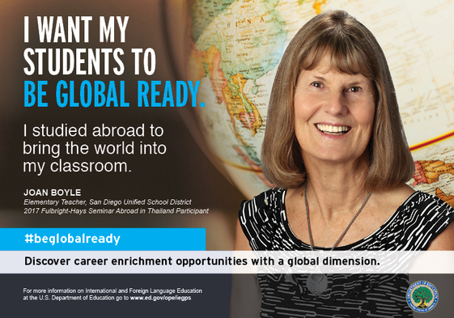

The IFLE office of the U.S. Department of Education is proud to debut a new series of images and messages to encourage U.S. students, teachers, and citizens to "be global ready."

Please visit our website to download the #BeGlobalReady series. We encourage you to use the images and messages in your schools, classrooms, and communities to spread the word about the value of international and foreign language education!
Image files are available for free download and use at the link below.

OPPORTUNITIES

K–16 Teachers: Attend a 2018 Summer Institute at a Title VI National Resource Center
There are 100 federally funded Title VI National Resource Centers (NRCs) at universities around the United States. Their many functions include providing curriculum materials, teacher education, travel opportunities for teachers, and scholarly speakers. Through the centers' websites, you can find a wide array of resources, such as lesson plans, culture boxes (for educators with a desire to use real artifacts from a particular world region in their classrooms), Skype-based classroom speakers, and more.

Many NRCs also organize summer institutes for teachers. Some institutes have funding to defray travel expenses for out-of-town participants. The University of California, Berkeley has compiled a list of summer institutes for teachers around the country. Information is posted as it becomes available.

ENGAGE WITH US

Follow Us on Twitter @GoGlobalED
IFLE is on Twitter with the latest from the world of international and foreign language education. Follow us @GoGlobalED and tell your friends! We'll see you in the Twittersphere!

Subscribe to Our YouTube Channel!
We're on YouTube with informative webinars and exciting grant program videos. Subscribe to IFLE's YouTube channel to enjoy the latest content!

Join Our FLAS and Fulbright-Hays Alumni Groups on LinkedIn
Have you received a Foreign Language and Area Studies (FLAS) fellowship or participated in a Fulbright-Hays grant program? Join our alumni groups on LinkedIn!
FLAS Program Alumni Fulbright-Hays Program Alumni

Intern With IFLE!
We seek motivated students who are anxious to learn and work as part of our team during an unpaid full- or part-time internship during the summer, fall, and/or spring. Visit our website for more information.

Send Us Your Feedback and Comments
We want to hear from you! Do you have suggestions for webinar topics? Ideas for things to include in future newsletters? Send them to Carolyn Collins at carolyn.collins@ed.gov.

INSPIRATION
If you know someone who would like to receive the IFLE newsletter, encourage them to sign up HERE!

